**Addressing Table**

|  |  |  |  |
| --- | --- | --- | --- |
| **Device** | **Interface** | **IP Address** | **Default Gateway** |
| College | G0/0 | 10.10.10.1/24 | N/A |
|  | *G0/0* | 2001:DB8:ACAD:100::1/64 | *N/A* |
|  | G0/1 | 10.10.11.1/24 | N/A |
|  | *G0/1* | 2001:DB8:ACAD:200::1/64 | *N/A* |
| Class-A | VLAN 1 | 10.10.10.100/24 | 10.10.10.1 |
| Class-B | VLAN 1 | 10.10.11.100/24 | 10.10.11.1 |
| Student-1 | NIC | 10.10.10.101/24 | 10.10.10.1 |
|  |  | 2001:DB8:ACAD:100::50/64 | FE80::2 |
| Student-2 | NIC | 10.10.10.102/24 | 10.10.10.1 |
|  |  | 2001:DB8:ACAD:100::60/64 | FE80::2 |
| Student-3 | NIC | 10.10.11.101/24 | 10.10.11.1 |
|  |  | 2001:DB8:ACAD:200::50/64 | FE80::3 |
| Student-4 | NIC | 10.10.11.102/24 | 10.10.11.1 |
|  |  | 2001:DB8:ACAD:200::60/64 | FE80::3 |

**College Router:**

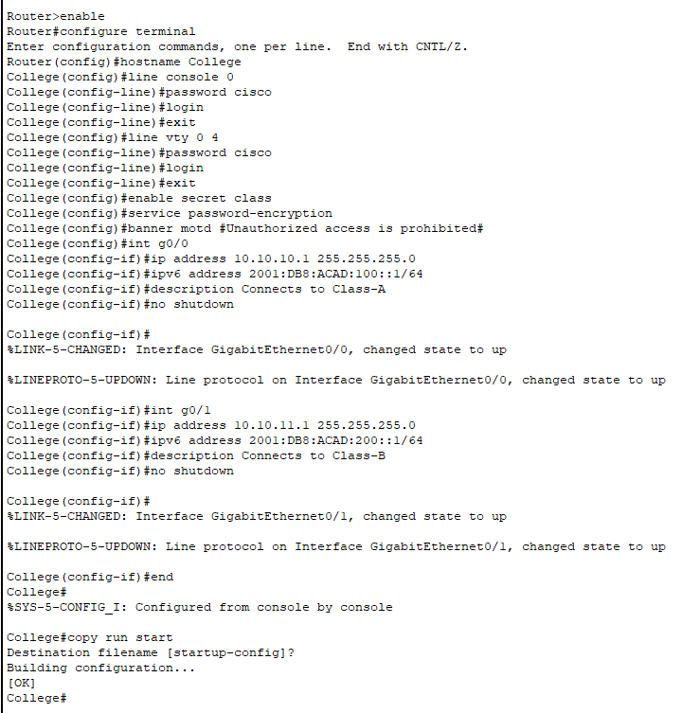

**Class-B Switch:**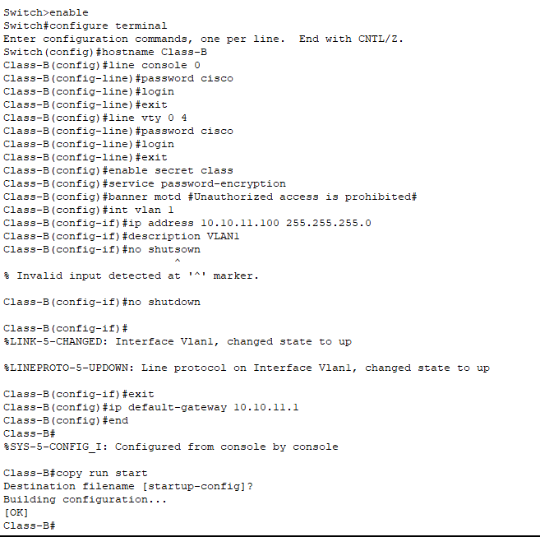

**PCs host:** 